Cambridge Champs Junior Sculling Head
Sunday 10th March 2012
Boating information – Visiting Crews

All non-Cambridge clubs should boat from the Combined Colleges Boathouse compound at Logan’s Way and MUST get permission to boat from the Bursar of Churchill College (see the Permission Form on Page 2 below).
Please park cars in Logan’s Way (giving due consideration to neighbouring establishments) - do not park in the compound (this is to allow space for trailers and boats). The compound will be open from 08:30 on race day.

To find Combined Colleges Boathouse (post code - CB4 1BL)
At the Elizabeth Way roundabout (at the end of Chesterton Road on the north side of the River Cam) take the 2nd exit past Elizabeth House (GE company building) heading to Chesterton High Street. Take the first right into Church Street, follow the road (flows into St Andrews Road) and go past St Andrews Church on your right, pass the large white office building and the old Pye offices (wavy roof). Take the next left into Logan’s Way, passing an office car park on your left, and continue to the end of the road - the combined Colleges boathouse compound is through the gates. For visiting cars please park outside the compound to allow vehicles with trailers to park.
Multimap link:
http://www.multimap.com/maps/?qs=cb4+1bl&countryCode=GB&mapData=

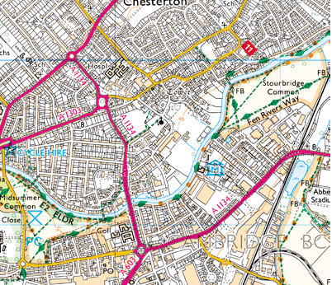
ELIZABETH WAY ROUNDABOUT
COMBINED COLLEGES BOATHOUSE
LOGANS WAY, CAMBRIDGE
CB4 1BL

If you have any queries, please telephone us any evening during the week prior to the race, before 10pm, or email us.

Best wishes
Lesley Corbett
Events Secretary, Champion of the Thames RC
t: 07769 651218
e: events.secretary@championrowing.org.uk

COMBINED COLLEGES BOATHOUSE
Logan’s Way
Cambridge CB4 1BL

The Combined Colleges are: Selwyn College, Kings College, Churchill College and the Leys School. Queries should be addressed in the first instance to the Bursar of Churchill College: bursar@chu.cam.ac.uk, t: 01223 336112; fax: 01223 336177.

Clubs, schools and organisations using the Boathouse or the land belonging to the Boathouse must agree to the following terms and conditions:

- Users must have their own insurance for their own equipment and any equipment they use which belongs to the Boathouse or to the College clubs that are members of the Boathouse.
- Selwyn College, Kings College, Churchill College and the Leys will not accept any liability for any personal injury, loss or damage incurred on the premises of the Boathouse or its surrounding land.
- Users must obtain permission from the Combined Colleges by completing the form below before using the premises or the land. Permission should be sought from the Bursar of Churchill College. On each occasion that use of the premises or land is made, permission must be sought in advance.
- The combined colleges reserve the right to levy fees in respect of the use of the facility. Any damage will be charged for.
- Users must leave the premises and land in a tidy state and depart promptly after races have ended.
- Vehicles will be parked outside the Boathouse compound, with due consideration to neighbouring establishments.
- Users are responsible for ensuring that the Boathouse (if used) and the entrance gate are locked on departure.
- Users must ensure that their rowers/members are properly trained in the use of any equipment on the site and that unnecessary risks are not undertaken, also that boats used on the site are properly licensed and obey the rules of the river.

An authorised officer of the club should complete and sign one copy of the document below and return it to:
The Bursar, Churchill College, Storey’s Way, Cambridge, CB3 0DS
(fax: 01223 336177).

I agree to abide by the conditions set out above on behalf of the club:

Club Name: Officer’s name:

Officer’s signature:

Contact address:

Contact telephone number:

